input() function use:

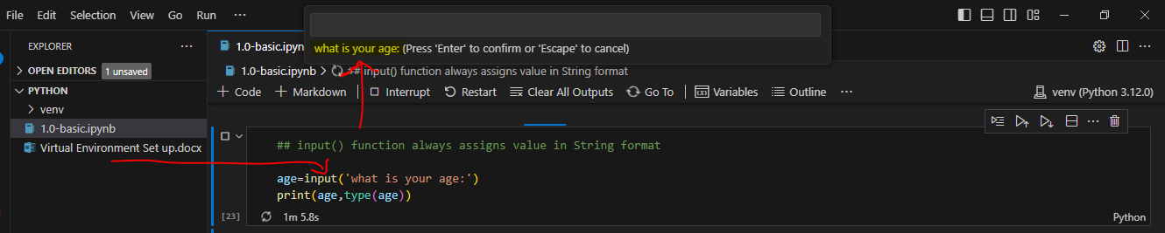

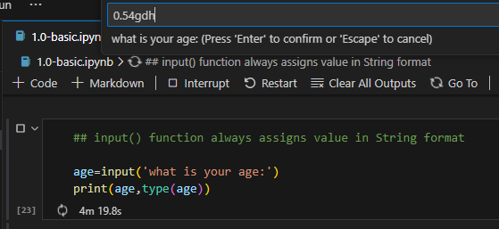

Input function always accepts changes any input value in ‘**String’** data type by default.

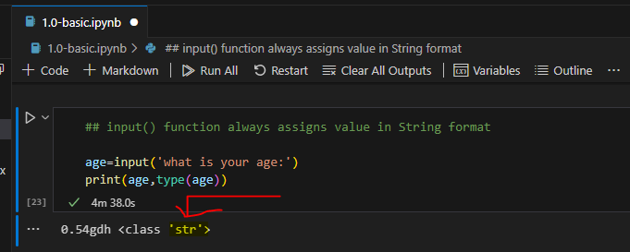

**int(input())** will accept only **integer** value, and will not accept any other data type value.

